UNIT8 Sports
Lesson style: Reading lesson

Brief Introduction of Unit8
This unit mainly talks about sports, which refers to all kinds of events, the Olympics and sports hobbies and interests. Language study takes on some key words about sports; and grammar is Passive voice which is also connected with the topic “sports”.
Teaching aims:
▲Grasp words, phrases and sentence patterns about sports and the Olympics.
▲Train the students’ reading ability
▲How to choose proper information and organize a composition
▲Educate the students to love sports and nature, becoming a useful person for society.
Class hour arrangement:

▲Reading --- 1 class
▲Language Points --- 1 Class
▲Integrating skills --- 1 Class
▲Grammar--- 2/3 Classes

Teaching methods:
Task-based method; Situational method; Heuristic method

Teaching aids:
Muti-media classroom

Design different teaching plans according to Class hour.
Class1 Reading
Teaching aims:
▲Get the general idea by skimming.
▲Get more details about the text by scanning.
▲Retell the text according to the structure of it, making the key words, Phrases and sentence patterns reappear.
- Write a short passage on the effects of holding the Olympics, helping connect reading with writing properly.
Teaching important points:
Train the Ss’ reading ability.
Teaching steps:

I. Bring out the theme (2 minutes)
Bring out the theme by Healthy song sung by FanXiaoxuan.

健康歌
T: What do you think of healthy song when hearing it?
S: Life lies in sports.
T: In a person’s life, whether you are a child, a young person, a middle-age person or an old one, It is a must for everyone to do sports. If you are ill, this will bring endless trouble to your work and study. We ourselves not only take exercise every day but also watch some wonderful sports meeting.
T: Could you tell me the names of different sports meeting?
S: Animals games, Paralympic games, the World University Games, National Games and The Asian Games
T: Which do you know is the greatest sports meeting in the world?
S: It’s the Olympic Games.
T: How much do you know about the Olympic Games?
Now please read the short passage about the Olympics below
Complete the words according to the first letter of every word.

II. Lead-in (2 minutes)
Purpose: Make the students learn something about the Olympics and take on some words and phrases describing sports and the Olympics to prepare for the part reading.

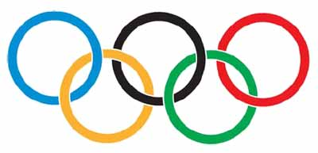

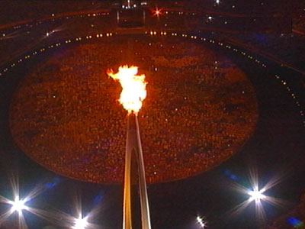
The ancient Olympic Games began around the year 776BC in Greece. It was about 1120 years before the first modern Olympics was held in Greece. The five Olympic rings stand for five continents, which means the unity of five continents, competing for medals with the competitors from the world in a fair and friendly manner. The first Olympic Torch Relay was in 1928, which is the symbol of light, unity, friendship, peace and justice. It is a great honor for an athlete to take part in the Olympics, where they can have a chance to win a gold medal, win honor for their own country and even become famous and rich. As is the case, It is a great competition between countries to bid for the Olympics because it shows a country’s overall national power. Today we’re going to read a passage, you will get more information about the Olympics.

III. Reading
(I). Skimming
Let the Ss skim the text and answer the two questions below.
Then try to find key words or phrases to sum up the general idea of
each paragraph.
Questions:
- How often are the Summer Olympic Games and the Winter Olympic Games held?
- How many countries and athletes did participate in the 2000 Olympic Games?
How many gold medals did the Chinese team win?
- When and where will the 29th Olympic Games be held?
Answers:
- Every four years
- Over 10,000 competitors from 227 countries; 28 gold medals, ranking third of all competing countries.
- In Beijing in 2008.

The general idea of each paragraph
Para1. the every-four-year Olympic Games
Para2. the ancient Olympic Games
Para3. the modern Olympic Games
Para4. the Olympic motto
Para5. the preparation for the 29th Olympic Games.
(II). Scanning
purpose: Scanning helps get more details about passage without looking through the whole passage.
Please scan the passage and fill in the form below.
The Olympic Games
 | The old Olympics | The modern Olympics
How often |  | Every four years
When and where First held | Around the year 776 BC in Greece | In Greece in 1896
Athletes | Only men | Both men and women
Events | Running, jumping | Horse riding, hammer throw...
The Olympic motto | Faster, Higher, Stronger
Preparation for the 29th Olympics | New buildings will be built  Make big changes Sports venues will be built  More trees will be planted  New roads will be built
(III). Cloze
Purpose: This is the general idea of the passage. Let the Ss fill in blanks according to the structure of it, using key words and phases.
The Olympic Games came from the old Olympics, which were held from 776BC to 393AD in Greece. Many of the sports at that time were the same as they are today, such as: running, jumping and wrestling. In addition, the games were only for men. On the contrary, the modern Olympics take place every four years, both men and women can compete for medals. Events are more wonderful, including some unusual events like horse-riding and hammer throw. All the athletes do their best to win medals as the Olympic motto says, “Faster, Higher, Stronger”. In the Sydney Olympics, Chinese team got 28 gold medals, ranking third of all the competing countries. However another great competition is not to win a medal but to host the Olympics. So it’s an great honor for China to hold the 29th Olympics, The people of the whole country are preparing for the coming Olympics.
IV. Practice
Purpose: Train the Ss to imitate and create by learning and
understanding key words and phrases.
Translate the following sentences into English, using the words
and phrases in brackets.
1.你知道中国国旗上的一颗大星星和小星星代表什么意思吗？ (stand for)
2.有多少运动员将参加下一届奥运会？(take part in/ join in)
3.小军是什么时候入团的？(join)
4.邮差每四天去那个山村送信。(every)
5.一共有八名选手在这次百米赛跑中角逐？(compete)
Answers:
- Do you know what the one big star and four smaller stars in China’s national flag stand for?
- How many athletes will take part in/ join in the next Olympic Games?
- When did Xiaojun join the League?
- The postman takes letters to that mountain village every four years.
- A total of eight athletes/ runners will compete in the 100-meter race.
V. Discussion
Hosting the Olympic Games is a great honor and a great responsibility. Being the host the Olympic Games will have good and bad effects on the host city. Now discuss with each other and then choose useful information to write down your opinion.
Purpose: This part is to train the Ss’ ability to analyze the problem dialectically (辨证地) and objectively.
Good effects | Bad effects
Learn more about the city, its country… | Cost much money
The city become more beautiful | Do harm to the environment
Help develop the city’s economy | Venues and buildings will be wasted
Promote international exchange | Traffic pressure
Strengthen friendship between the people all over the world. | Public order pressure
Promote sports undertakings | Offer chances to the terrorists

The Scientific Olympics

The Green Olympics


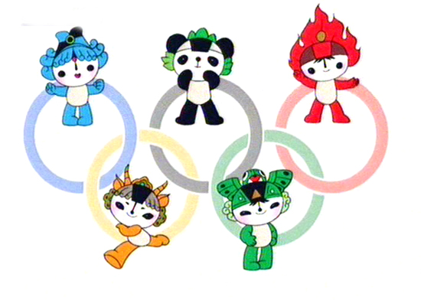

Sample Writing:
We have had a discussion about the effects of hosting the Olympics on the host city. Different persons have different opinions.
Some students agree that it’s a great honor for a country to host the Olympics, which shows its strong national power. Hosting the Olympics not only attracts a great many sports fans but also stimuli the development of economy. At the same time, it promote the international exchange and cooperation, and strength the friendship between people all over the world, which makes us think of the slogan of the Beijing Olympics “One world, One dream”.
However, the others think hosting the Olympics will make a bad difference to the host city. Above all, it will cost a great of money. For example, the bird-nest project is worth about 3.5 billion. Secondly, a great number of people can lead to the pressure in traffic and public order during the Olympics. So they say that it is not necessary to host it.
I am for the former opinion. Only when we take effective steps to solve the existing difficulty, will we be able to succeed in hosting a Scientific and Green Olympics.

VII. Homework
Please recite the general idea
Write a passage about “effects of Hosting the Olympics”

VIII. Teaching conclusion
点题
呈现单元主题

导课
呈现关键词
为阅读作准备



略读
获取大意
作业
课堂巩固与延伸
寻读
细节
讨论
辨证客观看问题
填空
凝聚信息
练习
模仿创造

XI. Teaching Reconsidering
阅读课教学在于向学生渗透阅读技巧，提高阅读能力。尤其人教版改版后，教材内容丰富多彩，与实际生活联系更加紧密，因此每单元阅读课前面的点题与导课是必不可少，使学生对阅读材料的背景有所了解，这也就是“未成曲调先有情”。阅读过程中设置的每一个环节：略读、寻读、复述、练习、讨论、背诵与写作，都是在为提高阅读能力所采取的措施， 步步为营，扎扎实实，使学生在阅读课上的确是学有所获，这可概括为“一枝一叶总关情”. 通过教材的综合运用，挖掘教材潜力，结合实际生活，提高学生阅读兴趣和阅读能力，使教材复习确实卓有成效.

